# **2023 NBLC CHRISTMAS PARTY COMPETITION**

# Judging

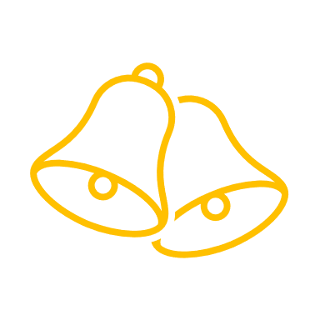 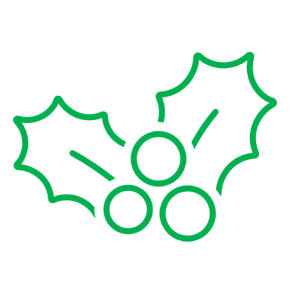

The competition will be judged by club members at the 2023 Christmas Party. It is not about the best technique but appeal and originality. Each member attending the party will be given a token to vote on their favourite entry.

# Topic

Animals

Use your imagination – Cast, Engraved, Enamelled, Cabbed, Carved or Facet. Jewellery representing your pet or for your pet 😊. Cabbed stones that look like fish. Stones with spiders made from the facets.

# Material

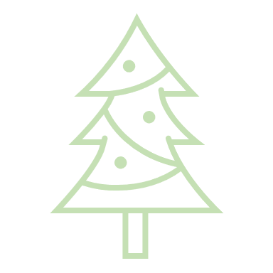 There is no restriction on materials used. 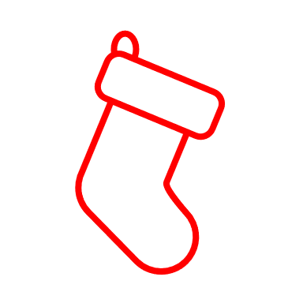

# To Enter

Place the entry in the box (located on the duty officers’ desk), along with completed details below by Friday 1st December 2023

Maximum 3 entries per person

# **2023 Christmas Party Competition**

Name ________________________________________________

Description of item and any packing materials you wish returned.