# **2024 NBLC CHRISTMAS PARTY COMPETITION**

# Judging

The competition will be judged by club members at the Christmas Party. It is not about the best technique but appeal and originality. Each member attending the party will be given a token on arrival to vote on their favourite entry.

Topic

Botanical/Landscape

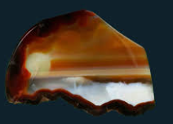

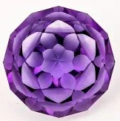 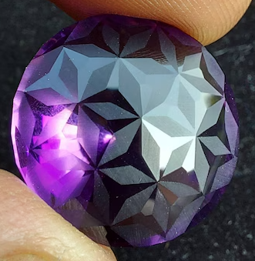

# Material

There is no restriction on materials used.

# To Enter

Place the entry in the box (located on the duty officers’ desk nearer the time), along with completed details below by Friday 6th December 2024

# **2024 Christmas Party competition**

Name ________________________________________________________________

Description ­­­­­­­­­­­­­­­­­­­­­­­_______________________________________________________