# **NBLC CHRISTMAS PARTY COMPETITION 2025**

# Judging

The competition will be judged by club members at the Christmas Party. It is not about the best technique but appeal and originality. Each member attending the party will be given a token on arrival to vote on their favourite entry.

Topic is Space

Just some examples for inspiration.

* Use rocks/gemstones that can been found in meteorites (no certificate needed to prove it was formed in space). Such as Peridot or Opal.
* Or rocks that looks like a small piece of space.
* Metal smithing can base their piece for example around stars or the moon or planets. Or use some moonstone.

Below are just a few ideas

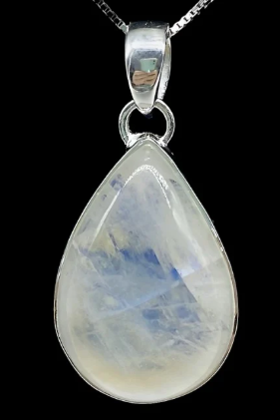 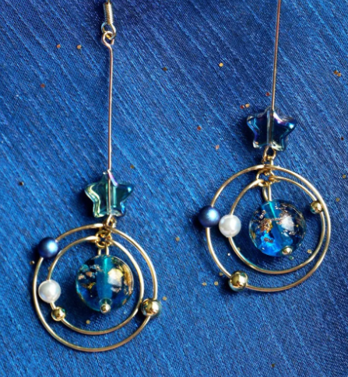 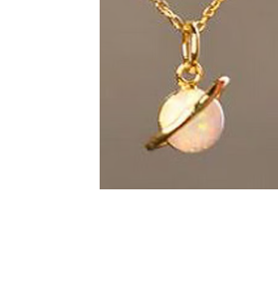 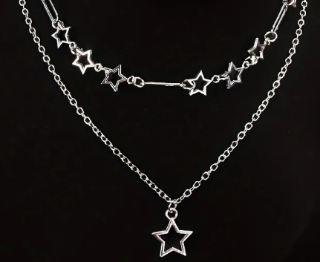

# Material

There is no restriction on materials used.

# To Enter

Place the entry in the box (located on the duty officers’ desk nearer the time), along with completed details below by 12th December 2025

# **Christmas Party competition**

Name ________________________________________________________________

Description ­­­­­­­­­­­­­­­­­­­­­­­_______________________________________________________